Meta title (60) | Jabalpur Hospital Case Study | Healthray HMS
Meta description (160) | See how Jabalpur Hospital used Healthray HMS to improve patient information, diagnostics, pharmacy, billing, TPA processing and operational visibility.

Hospital | BBMH Hospital
Location | Cuttack, Odisha, India
Type | Multispeciality
Size | 100 beds
Time to go live | Under 2 weeks
Downtime | None
Website | https://www.bbmh.in/
Modules used:
- Patient Records
- Billing
- Staff & Task Management
- Reporting
- Laboratory

How BBMH Hospital Digitised Operations and Cut Administrative Workload by 35%
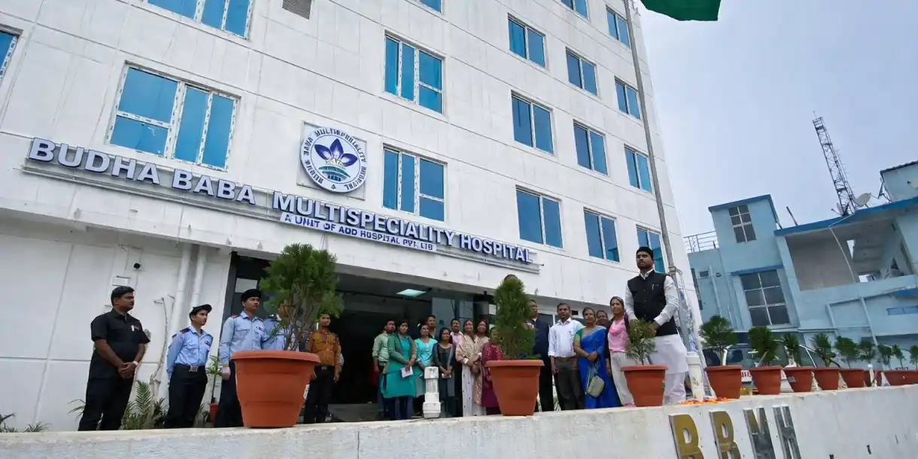
BBMH Hospital is a 100-bedded multispeciality hospital in Cuttack, Odisha, with 50+ doctors. Its front desk, clinical and billing operations now work together through digital workflows, reducing administrative work by 35%.
35% reduction  in administrative workload | 30% faster  billing and discharge processing | 40% fewer  manual errors across operations | 20% faster access to operational information

A growing hospital facing administrative challenges
BBMH provides advanced laboratory and imaging services, ICU care, cath lab services, and multiple clinical and surgical specialities, along with 24×7 emergency services. As its patient volume increased, managing the hospital's internal processes became harder.
Information was spread across paper files, spreadsheets and different systems. Administrative teams spent considerable time searching for information, tracking data and handling follow-ups, while doctors were also pulled into administrative work.

Four challenges affecting BBMH's hospital operations

01 – Scattered Information
Patient records, billing information and reports were spread across paper files, spreadsheets and different systems, making information harder to find.

02 – Manual Workflows
Billing and record-keeping involved manual processes and repeated cross-checking, making routine administrative work more time-consuming.

03 – Limited Visibility
Management did not have timely access to information about hospital activities. Reports took time to compile, making it harder to get a clear view of operations.

04 – Administrative Burden
Internal coordination and follow-ups were taking doctors and teams away from their core responsibilities.

Why BBMH chose Healthray
BBMH needed to move away from scattered records and manual processes while keeping billing, patient information and reporting connected. It chose Healthray HMS to centralise these workflows, reduce administrative follow-ups and give teams faster access to operational information.
“Moving to Healthray made the shift to digital hospital management much easier for us. Our existing data was migrated smoothly, and our teams moved to the new system without disrupting hospital operations.”
Dr. Umesh Ray
BBMH Hospital

How Healthray helped BBMH digitise operations

01 – Centralised hospital information
Healthray's Patient Records module brought patient information into one digital system, reducing the need to search across paper files, spreadsheets and separate sources.

02 – Digital billing
The Billing module reduced manual data handling and helped teams process billing and discharge activities faster.

03 – Faster operational reporting
Reporting tools gave teams and management quicker access to hospital information instead of relying on manually compiled reports.

04 – Better task coordination
Staff & Task Management helped teams organise follow-ups and routine activities digitally, reducing manual coordination.

From data migration to team onboarding
BBMH moved to Healthray without disrupting its ongoing hospital operations.
01 – 1 day

Data migration
BBMH's existing data was migrated to Healthray within one day.
02 – Under 2 weeks

Implementation
Healthray HMS went live within two weeks without disrupting hospital operations.
03 – Training and adoption

Teams onboarded
Doctors and teams were onboarded to Healthray and its digital workflows.

Results from Healthray implementation
The move to digital hospital management delivered measurable improvements at BBMH.

35% reduction in administrative workload
Reduced manual tracking, follow-ups and routine administrative work helped lower the overall workload.

30% faster billing and discharge processing
Digital billing workflows helped streamline billing and discharge activities.

40% fewer manual errors
Reducing manual data handling and repeated cross-checking helped improve accuracy.

20% faster access to operational information
Digital access to hospital information gave teams and management a clearer view of hospital activities and processes.

BBMH's operations before and after Healthray
Area | Before | After Healthray
Information | Stored in different places | Managed in one digital system
Administrative work | Time spent on routine tasks | Reduced administrative workload
Management reporting | Reports took time to compile | Faster access to reports
Team coordination | Teams relied on manual follow-ups | Teams manage follow-ups digitally
Billing & discharge | Manual processing | 30% faster processing
Manual errors | Data entry errors | 40% fewer manual errors

Is your hospital facing similar challenges?
BBMH's experience may be relevant if your hospital:
- Relies on paper records, spreadsheets or disconnected systems.
- Spends significant time on administrative follow-ups.
- Finds it difficult to access operational information quickly.
- Wants to reduce manual work across hospital operations.
- Needs to digitise processes without disrupting ongoing activities.

See how Healthray HMS can work for your hospital
Book a free demo. Our team will show you how to move your hospital operations from manual processes to digital workflows.
CTA Button: Book a Demo

